**REQUIREMENT ANALYSIS**

**Technical Requirements**

|  |  |
| --- | --- |
| Date | 28 JUNE 2025 |
| Team ID | LTVIP2025TMID59766 |
| Project Name | **TrafficTelligence: Advanced Traffic Volume Estimation with Machine Learning** |
| Maximum Marks | 4 Marks |

**Technical Requirements:**

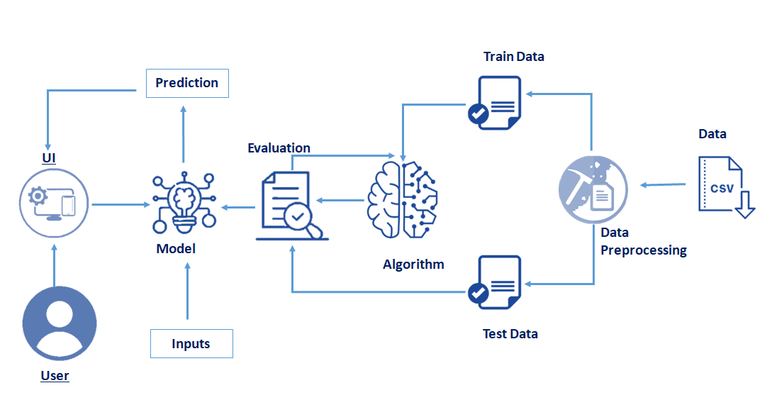

| **Category** | **Details** |
| --- | --- |
|  |  |
| **Programming Languages** | Python (ML/Backend), JavaScript (Frontend), SQL |
| **Frameworks/Libraries** | TensorFlow, Scikit-Learn, OpenCV (if CV used), Flask/Django (backend), React/Angular (frontend) |
| **Database** | PostgreSQL, MongoDB, or MySQL |
| **Cloud Platforms** | AWS, Google Cloud, Azure (for hosting, storage, compute) |
| **Data Storage** | Cloud Storage, SQL/NoSQL databases |
| **APIs** | RESTful APIs for external data integration (weather, maps, events) |
| **Data Visualization Tools** | Plotly, Dash, Power BI, Tableau, D3.js |
| **Hardware Requirements** | Servers, Edge Devices, Traffic Cameras, IoT Sensors |
| **Security Requirements** | Data encryption, Secure API endpoints, User authentication (OAuth, JWT) |
| **Deployment Tools** | Docker, Kubernetes, CI/CD pipelines |
| **Scalability** | Auto-scaling cloud services, Load balancing |

**User Interface:**

| **Page/Module** | **UI Elements** |
| --- | --- |
| **Login Page** | Username, Password, Login Button, Forgot Password, Sign Up (optional) |
| **Dashboard (Main)** | Traffic Map, Current Traffic Status, Real-Time Traffic Volume Chart, Notifications, Weather Overlay, Filters (location, time) |
| **Prediction Module** | Input Parameters (date, time, location), Show Prediction Button, Result Display (graph/chart), Export Option |
| **Historical Data** | Date/Time Picker, Traffic Volume Graph, Heatmaps, Download Data Button |
| **Alerts & Notifications** | List of Congestion Alerts, Custom Alert Setup, Toggle Notifications |
| **Reports** | Generate Report Button, Download (PDF/Excel), Charts/Statistics View |
| **Admin Panel** | Manage Users, Data Sources, API Keys, System Logs, Settings |
| **Help/Support** | FAQs, Contact Support Form, User Guide |
|  |  |